**EXPERIMENT-8**

**SAILOR BOAT DATABASE (DDL, DML, DQL, Sub query, Joins, Set operations)**

**Aim:**

* Create sailors, boats, and reserves.(foreign key)
* Insert 5 values each table.
* Display all records.
* Find the names and ages of all sailors.
* Find all sailors with ratings above 8.
* Find sailors name with rating above 7 & age above 25.
* Display all the names & colors of the boats.
* Find all the boats with Red colors.
* Find the names of sailors' who have reserved boat number 103.
* Find the sids of sailors who have reserved blue boat
* Find the names of sailors' who have reserved Red boat.
* Find the colours of boats reserved by some name(provide any name in table).
* Find the names of the sailors who have reserved at least one boat.
* Find the names of the sailors who have reserved two different boats.
* Find the names of sailors who have reserved a Red or a Green boat.(union)
* Find the names of sailors who have reserved both a Red and a Green boat.
* Find the names of sailors who have reserved boat 103.(nested query)
* Find the names of sailors who have reserved red boat.(nq)
* Find the names of sailors who have not reserved red boat.(nq)
* Find the names of sailors who have reserved boat number 103.(exists)
* Find sailors whose rating is better than some sailors called name.
* Find sailors whose rating is better than every sailor' called name.
* Find the sailors with highest rating.
* Find the average age of all sailors.
* Find the average age of sailors with a rating of 10.
* Count the number of sailors.
* Count the number of different sailor ratings.
* Find the name and age of the oldest sailor.
* Find the names of the sailors who are older than the oldest sailor with a rating of 10.
* Find the age of youngest sailor for each rating level.
* Find the age of the youngest sailor who is eligible to vote (i.e., is at least 18 years old) for each rating level with at least two such sailors.
* For each red boat, find the number of reservations for this boat.
* Find all sailors name according to names.
* Find all sailors details according to rating.
* Find all sailors details according to rating(highest first) if ratings are same then according to age(youngest first).

**Components:**

* Instance: It is a collection of information stored in a database at a particular moment.
* Entity: Object that is relevant to the given system. It is represents as a rectangle.
* Attribute: Trait of an entity , relationship or other attribute .It is represented by oval.

**Schema:**

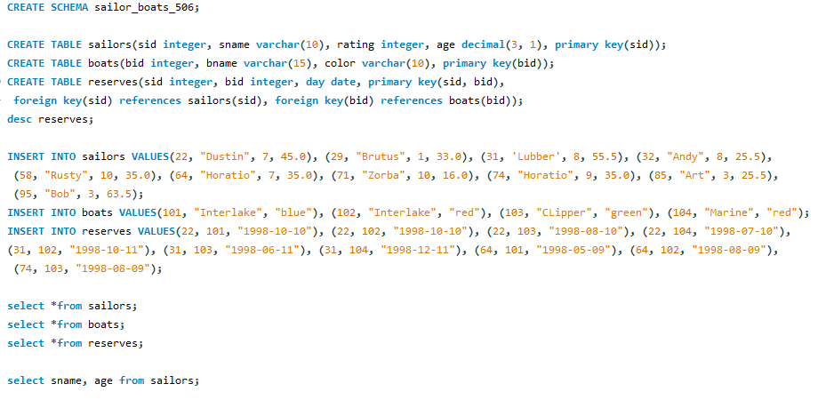

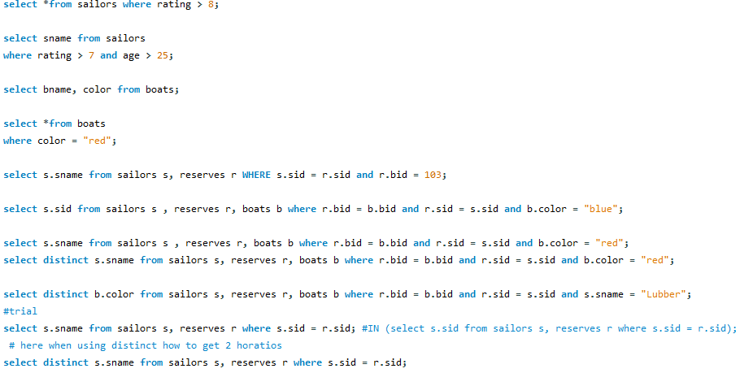

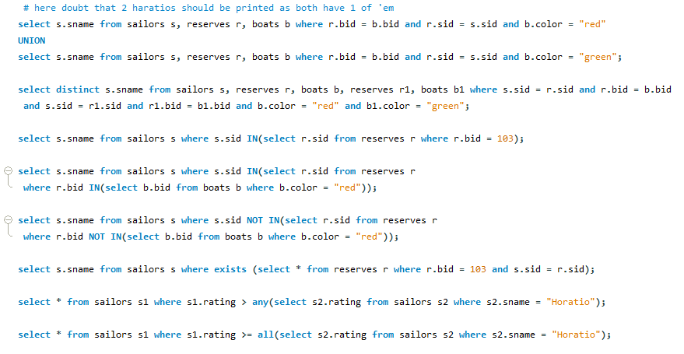

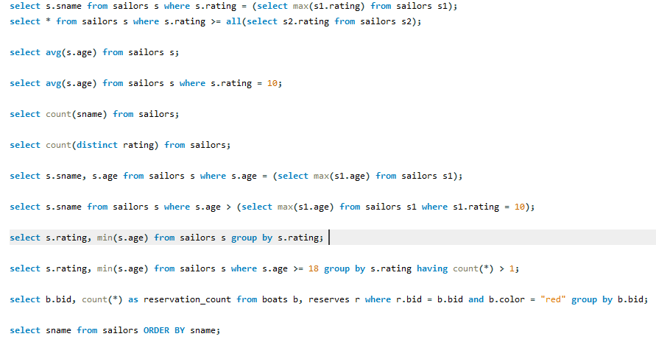

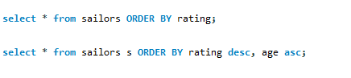

**Output:**

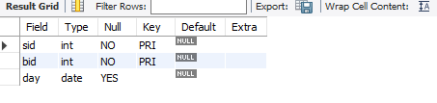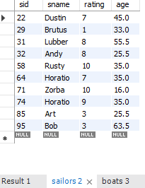

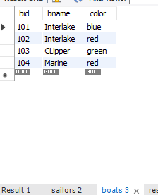

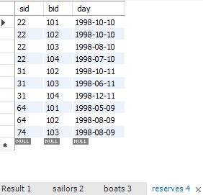

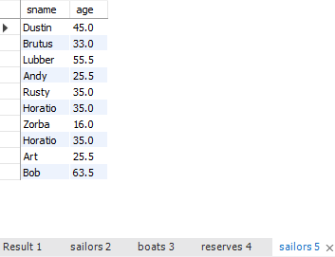

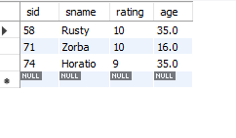

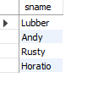

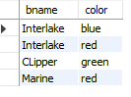

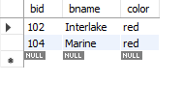

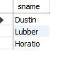

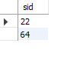

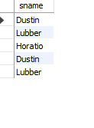

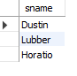

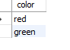

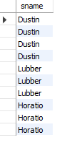

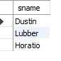

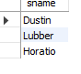

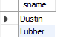

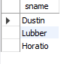



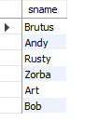

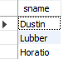

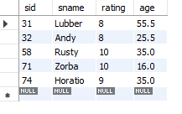

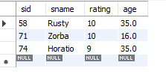

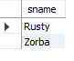

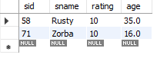

C:\Users\hi\Pictures\Screenshots\27.png

C:\Users\hi\Pictures\Screenshots\28.png

C:\Users\hi\Pictures\Screenshots\29.png

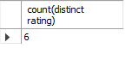

C:\Users\hi\Pictures\Screenshots\31.png

